

VILLAGE OF MOUNT PROSPECT

MONTHLY FINANCIAL REPORT

January 31, 2024

Prepared By

Amit Thakkar, CPA
Director of Finance

TO: village president, board of trustees, and finance commission

FROM: amit thakkar, director of finance

DATE: march 13, 2024

SUBJECT: monthly financial report for the month of january 2024

In an effort to provide the most transparent and relevant financial information in a timely manner, we are submitting this report herewith. The report contains relevant data and analytical information for the Village's financial affairs. The report is prepared based on the most recent available financial information (internal and external). The report is divided into five sections, including a) Cash and Investments, b) Revenues, c) Expenses, d) Fund Balance Analysis, and e) Other items that may contain relevant new issues and items representing and impacting the Village's financial interest and well-being.

- Cash and Investments

The Village of Mount Prospect maintains a sufficient liquid cash balance at various banking and investment institutions for the smooth operation of the Village's day-to-day activities. The remainder of the cash assets are invested in multiple interest-earning accounts and investment options in accordance with the Village's Investment Policy. As of January 1, 2024, the beginning Cash and Cash Equivalents totaled $109.2 million. During the month, the Village collected cash receipts totaling $8.7 million. The investment income for the month totaled $494,828. The monthly payroll cost was $2.0 million, and accounts payable were paid in the amount of $8.2 million. The inter-fund activity increased the cash position by $7,254, while other disbursements totaled $15,941. As of January 31, 2024, the Village's Cash and Cash Equivalents totaled $109.3 million.
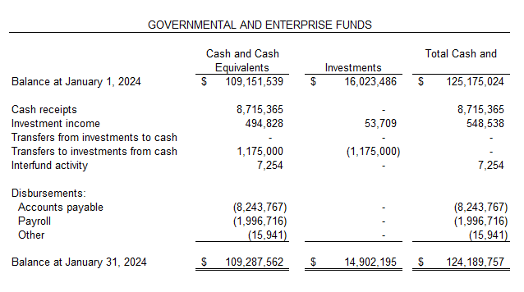
As of January 31, 2024, the Village has $14.9 million invested in long-term investment options, including U.S. Treasury, AAA+ rated money-market funds, and FDIC-insured CDs. The Cash, Cash Equivalents, and Investments totaled $124.2 million as of January 31, 2024.

The table below summarizes the Cash and Cash Equivalents by Fund type as of January 31, 2024.
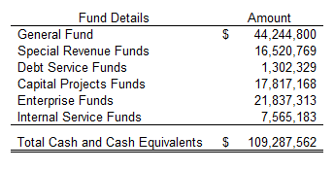
In addition to the funds summarized above, the Village of Mount Prospect has $1,293,874 in Escrow Accounts under the umbrella of Other Trust and Agency Funds.

- Revenues

The data below summarizes the revenue recognized by the Village during January 2024.

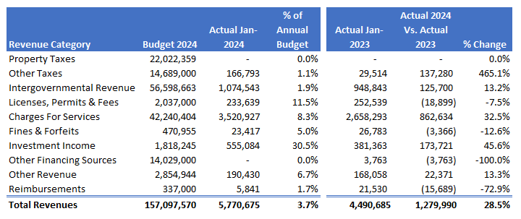
The above amounts do not represent all the revenues to be recognized for the period under review. Certain state taxes, such as sales tax, home rule sales tax, and a few other taxes, will be received by the Village in February 2024 and later. Additionally, during January 2024, the Village received the following revenues from the State, which relate to a period prior to January 2024. These amounts are distributed after the State administrative fee deductions of $10,217.
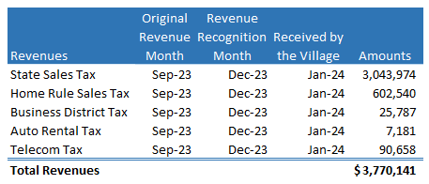

The actual revenue recognized by the Village totaled $5.8 million in January 2024, representing 3.7 percent of the annual budget. The Village does not receive any significant revenue in the early part of the year. During the first three months of the year, it usually collects revenues for the last quarter of the previous year.

Property Taxes: The Village's total levy for the year is $19,469,004. The total property tax revenue budget, including TIF revenues, is $22.0 million. The Village has not collected any property taxes in January 2024. The property taxes are due in two installments, one in March and one in August. The Village receives its property tax distributions from the County between March and December.

Other Taxes: The category of Other Taxes includes all the taxes enacted per local ordinances, including Home Rule Sales Tax, Hotel/Motel, Food and Beverage, Municipal Motor Fuel Tax, Utility Taxes, etc. As the State collects some of these taxes, there is a three-month lag between the actual sales and the tax remittance. In addition, all the local economic activities for January are reported in February or later. The YTD tax collection under this category totals $166,793. It is too early to provide a commentary or comparison for the category.

Intergovernmental Revenue: This category includes all the State shared taxes, including State Sales Tax, Income Tax, Use Tax, Motor Fuel Tax, and Grants. The Village is vigilantly tracking all intergovernmental revenues. As most of these taxes are collected by the State, there is a three-month lag between the actual sales and the tax remittance. The Village recognized $1,074,543 in intergovernmental revenues during January 2024. The amount does not represent the total revenues to be recognized during the month, as major revenues will be reported and collected after January 2024. The overall recognized revenues are trending higher by $125,700 compared to the amount recognized last year for the same period. The recognized revenues include income tax - $906,759, personal property replacement tax - $119,235, and federal grants totaling $48,548.

Licenses & Permits: The Village collected $233,639 in License and permit Fees in January 2024. This amount is trending lower by $18,899, or 7.5 percent, compared to last year’s collection.

Charges for Services: The Village collected $3.5 million in charges for services in January 2024. The amount represents 11.5 percent of the annual budget for the category, and it is trending higher by $862,634, or 13.2 percent, compared to last year’s collection at the same time, mainly due to the increased water/sewer and refuse rates.

Investment Income: The Village earned $555,084 in investment income during January 2024. The amount represents 30.5 percent of the annual budget for the category. The recognized revenue is trending higher by $173,721 or 45.6 percent compared to last year’s amount.

Other Categories: All other revenue categories have collectively generated $219,688 during January 2024. The amount mainly includes $23,417 in fines and forfeitures, $190,430 in other revenues, and $5,841 in reimbursements,

- Expenditures

The data below recaps the expenditures incurred during January 2024.
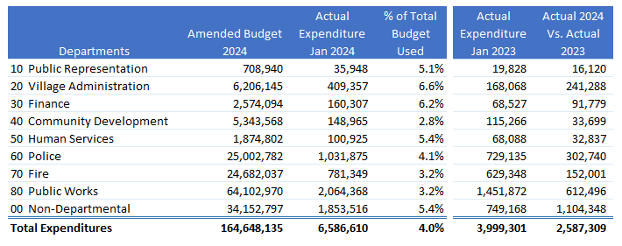
The above amounts do not include the expenditures for the Pension Funds, as they are separate entities. The above amounts are unaudited and subject to change with accrual/audit adjustments.

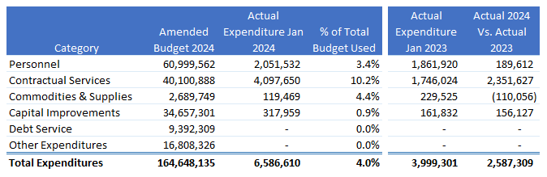

Personnel Costs: The year-to-date expenditures for Personnel Costs, including benefits, are $2.1 million, or 3.4 percent of the annual budget for the category. The amount is trending higher by $189,612 compared to January 2023. The overtime expense for January 2024 totaled $86,312, while at the same time last year, it totaled $78,952.

Contractual Services: This category covers most contractual services, including some large line items, such as JAWA water purchases, budgeted and grant-funded engineering studies, and other contracts. The Village incurred $4,097,650 in contractual services, equating to 10.2 percent of the annual budgeted amount for the category. The expenditure amount is trending higher by $2.4 million, mainly due to inflationary and timing issues.

Supplies: In January 2024, the Village spent $119,469 on supplies, which totaled 4.4 percent of the annual budget. At the same time last year, the Village had spent $229,525 in supplies. The variance represents timing issues with recognizing supplies-related expenditures in 2024.

Capital Improvements: The Village has $34.7 million in approved capital improvement projects for 2024. In March 2024, the village will propose a budget amendment to carry over $13.8 million in unfinished projects from 2023 to 2024. The Village has spent $317,959 on capital improvement projects during January 2024. The Village conducts major projects during the summer and concludes most projects in the fall and early winter.

Debt Service: Per the established debt service schedules, the Village's bond payments are due on June 1 and December 1. The Village processes these debt service payments a few days before due dates and keeps sufficient funds to execute them. The Village has not incurred any debt service expenditures during January 2024.

Other Expenditure: The Other Expenditure category includes all other expenditures not categorized above. The budget for this category includes $14.0 million in inter-fund transfers and $2.8 million in other expenditures. The Village has not incurred any expenditure under this category during January 2024.

d) Fund Balance Analysis:

The fund balance is an essential tool to check the fiscal health of any governmental organization. The data below summarizes the Village's monthly unassigned/unrestricted general fund reserves. The fund balance data is unaudited.

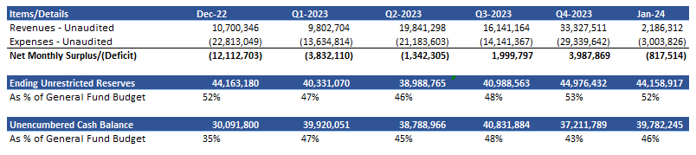
(Unaudited and Subject to Change)

The above fund balance analysis is not audited and is subject to change. As of January 31, 2024, the unrestricted fund balance is estimated at $44.2 million, which equates to 52 percent of the annual budget. Not all revenues and expenditures for the fiscal period are recognized, and the above amount will change as and when yearend accruals and adjustments are added. The yearend accruals and adjustments will further improve the ending restricted fund balance. Recently, the Village revised its Fund Balance Policy, and the new target is set to maintain the fund balance between 30 to 50 percent. Besides that, a new Economic Emergency Fund was established, and a transfer of $6.5 million was executed as initial funding from the General Fund reserves.

Economic Emergency Fund

The Village Board authorized the creation of a new Economic Emergency Fund in May 2023 and approved a budget amendment funding $6.5 million from the General Fund reserves as an initial funding amount. This transfer was executed in May 2023 and invested in June 2023 in a AAA-rated I-prime account. The table below summarizes the Economic Emergency Fund activities for the month. During January, the Economic Emergency Fund earned an interest income of $29,982, and at the end of the month, the total fund balance stood at $6,725,672.

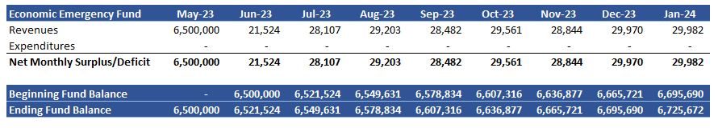

- Other Items:

  - During January 2024, the Village issued 80 real estate transfer tax stamps, of which 37 were exempt and 43 were non-exempt. During the month under review, the Village collected $46,053 in real estate transfer taxes. The average selling price for real estate was $356,912. At the same time last year (January 2023), the Village sold 65 transfer tax stamps, of which 36 were exempt and 29 were non-exempt. In the same month last year, the Village collected real estate transfer taxes of $46,092, and the average selling price was $529,771 (including large commercial transactions).

Respectfully Submitted,
Amit Thakkar
Director of Finance

