

VILLAGE OF MOUNT PROSPECT

MONTHLY FINANCIAL REPORT

November 30, 2024

Prepared By

Amit Thakkar, CPA
Director of Finance

TO: village president, board of trustees, and finance commission

FROM: amit Thakkar, director of finance

DATE: January 3, 2025

SUBJECT: monthly financial report for the month of November 2025

In an effort to provide the most transparent and relevant financial information in a timely manner, we are submitting this report herewith. The report contains relevant data and analytical information for the Village's financial affairs. The report is prepared based on the most recent available financial information (internal and external). The report is divided into five sections, including a) Cash and Investments, b) Revenues, c) Expenses, d) Fund Balance Analysis, and e) Other Items that may contain relevant new issues and items representing and impacting the Village's financial interest and well-being.

- Cash and Investments

The Village of Mount Prospect maintains a sufficient liquid cash balance at various banking and investment institutions for the smooth operation of the Village's day-to-day activities. The remainder of the cash assets are invested in multiple interest-earning accounts and investment options in accordance with the Village's Investment Policy. As of November 1, 2024, the beginning Cash and Cash Equivalents totaled $104.4 million. During the month, the Village collected cash receipts totaling $9.0 million. The investment income for the month totaled $481,581. The monthly payroll cost was $1.9 million, and accounts payable were paid in the amount of $13.3 million. The inter-fund activity increased the cash position by $3,210, while other disbursements totaled $35,727. During the month under review, the Village invested additional $500,000 from its liquid cash and cash equivalents. As of November 30, 2024, the Village's Cash and Cash Equivalents totaled $98.2 million.

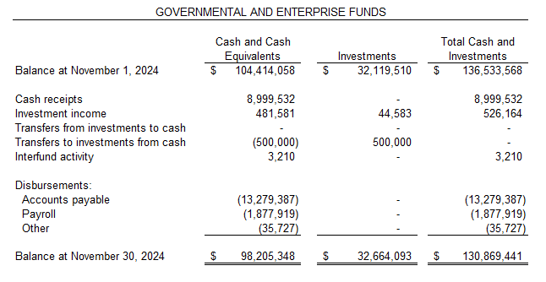

As of November 30, 2024, the Village has $32.7 million invested in long-term investments, including U.S. Treasury, AAA+ rated money-market funds, and FDIC-insured CDs. The Cash, Cash Equivalents, and Investments totaled $130.9 million as of November 30, 2024.

The table below summarizes the cash, cash equivalents, and investments by fund type as of November 30, 2024.
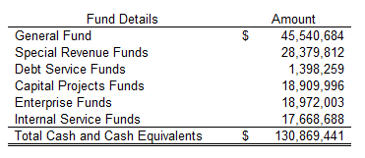

In addition to the funds summarized above, the Village of Mount Prospect has $1,301,680 in escrow accounts under the umbrella of Other Trust and Agency Funds.

- Revenues

The data below summarizes the revenue recognized by the Village through November 2024.
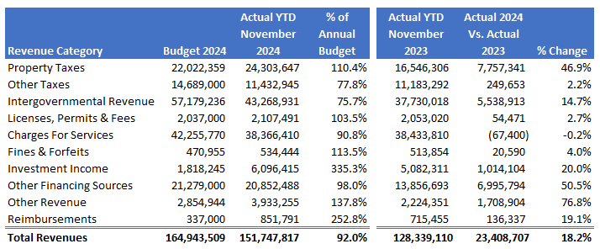
The above amounts do not represent all the revenues to be recognized for the period under review. Certain state taxes, such as sales tax, home rule sales tax, and a few other taxes, will be received by the Village in December 2024 and later. Additionally, during November 2024, the Village received the following revenues from the State, which relate to a period prior to November 2024. These amounts are distributed after the State administrative fee deductions of $12,010.
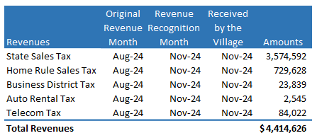

The actual revenue recognized by the Village totaled $151.7 million through November 2024, representing 92.0 percent of the annual budget. The overall recognized revenues are trending higher compared to the 2023 collection for the same period, except for the charges for services. The revenue collection is on track with an overall expected annual revenue cycle.

Property Taxes: The Village's total levy for the year is $19,469,004. The total property tax budget, including TIF increments, is $22.0 million. The Village collected $24.3 million in property taxes through November 2024. The property taxes are due in two installments, one in March and one in August. This year, the Village received its second installment on time from Cook County Treasurer’s Office. Last year, the County significantly delayed the second installment. The collected property taxes include higher-than-expected TIF increments for the Prospect & Main TIF district.

Other Taxes: The category of Other Taxes includes all the taxes enacted per local ordinances, including Home Rule Sales Tax, Hotel/Motel, Food and Beverage, Municipal Motor Fuel Tax, Utility Taxes, etc. As the State collects some of these taxes, there is a three-month lag between the actual sales and the tax remittance. In addition, all the local economic activities for November are reported in December or later. The YTD tax collection under this category totals $11.4 million, an increase of $249,653 or 2.2 percent compared to last year’s collection. The Village collected $1,575,630 in Food & Beverage Taxes and $971,440 in Real Estate Transfer Taxes through November 2024. The same was $1,429,172 and $888,842 last year, respectively. The Food & Beverage Tax reflects an increase of 10.3 percent over last year’s collection, while the Real Estate Transfer Tax reflects an increase of 9.3 percent over last year's collection.

Intergovernmental Revenue: This category includes all the State shared taxes, including State Sales Tax, Income Tax, Use Tax, Motor Fuel Tax, and Grants. The Village is vigilantly tracking all intergovernmental revenues. As most of these taxes are collected by the State, there is a three-month lag between the actual sales and the tax remittance. The Village recognized $43.3 million in intergovernmental revenues through November 2024. The amount does not represent the total revenues to be recognized during the month, as significant revenues will be reported and collected after November 2024. The overall recognized revenues are trending higher by $5.5 million, or 14.7 percent, compared to the amount recognized last year for the same period. Overall, the YTD 2024 state taxes collected are trending higher by $1.6 million or 7.0 percent compared to the 2023 collection for the same period. Due to the recent legislative changes, some portions of the State Use Tax are now collected as the State Sales Tax (from out-of-state online retailers). This shift is responsible for a reduction in the State Use Tax. The State sales tax reflects actual sales tax accrued from January through August, collected with a three-month lag between April and November. The State income tax revenue is recognized on a cash basis in the month of receipt and represents a 7.0 percent growth compared to the 2024 collections.

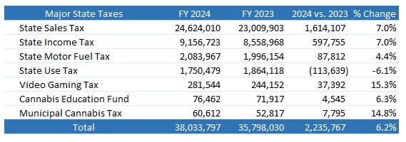

Licenses & Permits: The Village collected $2.1 million in license and permit fees through November 2024. This amount is trending higher by $54,471, or 2.7 percent, compared to last year’s collection. The overall collection represents 103.5 percent of the annul budget for the category.
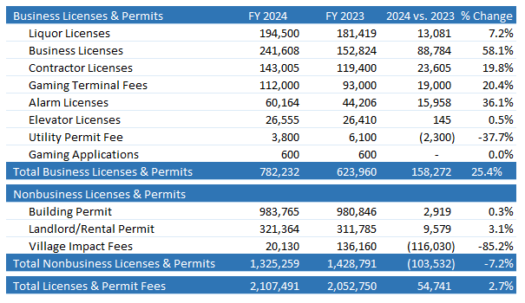

Charges for Services: The Village collected $38.4 million in charges for services through November 2024. The amount represents 90.8 percent of the annual budget for the category, and it is trending marginally lower by $67,400, or 0.2 percent, compared to last year’s collection. The expected collection for the category was initially higher. However, due to timing issues with the ambulance billing fees, especially for the GEMT (Ground Emergency Medical Transport), the amount reported is marginally lower compared to the 2023 collection. This timing issue is expected to be resolved in the near future.

Investment Income: The Village earned $6.1 million in investment income through November 2024, which represents 335.3 percent of the category's annual budget. The recognized revenue is trending higher by $1.0 million, or 20.0 percent, compared to last year’s amount.

Other Categories: All other revenue categories have collectively generated $26.2 million through November 2024. The amount mainly includes $534,444 in fines and forfeitures, $3.9 million in other revenues, $851,791 in reimbursements, and $20.8 million in Other Finance Sources (inter-fund transfers). The Village executed various budgeted inter-fund transfers through November 2024 as below.
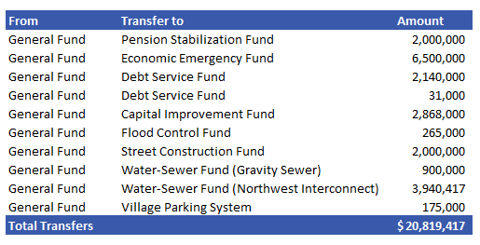
- Expenditures

The data below recaps the expenditures incurred through November 2024.
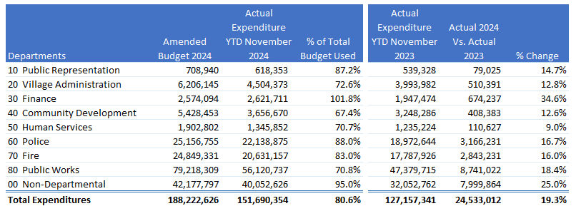

The above amounts do not include the expenditures for the Pension Funds, as they are separate entities. The above amounts are unaudited and subject to change with accrual/audit adjustments.

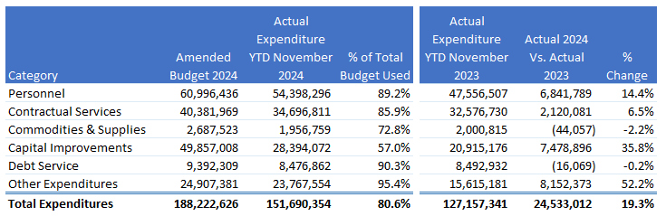

Personnel Costs: The year-to-date expenditures for Personnel Costs, including benefits, are $54.4 million, or 89.2 percent of the annual budget for the category. The amount is trending higher by $6.8 million compared to last year’s amount, mainly due to higher pension contributions for the year and cost-of-living adjustments for wages. The overtime expense through November 2024 totaled $2.98 million, while at the same time last year, it totaled $2.3 million. The Village is staffing the Fire Station 11 engine on an overtime basis. Additionally, an increased number of worker’s compensation claims has resulted in higher overtime for the year.

Contractual Services: This category covers most contractual services, including some large line items, such as JAWA water purchases, budgeted and grant-funded engineering studies, and other contracts. The Village incurred $34.7 million in contractual services, equating to 85.9 percent of the annual budgeted amount for the category. The expenditure amount is trending higher by $2.0 million, mainly due to inflationary and timing issues.

Supplies: Through November 2024, the Village spent $1.96 million on supplies, which totaled 72.8 percent of the annual budget. The commodities and supplies are on track as expected and marginally trending slightly lower due to timing issues.

Capital Improvements: The Village initially had $36.0 million in approved capital improvement projects for 2024. In March 2024, the Village Board approved a budget amendment to carry over $13.8 million in unfinished projects from 2023 to 2024. The Village has spent $28.4 million on capital improvement projects through November 2024. The Village conducts major projects during the summer and concludes most projects in the fall and early winter. The Village is expected to book major expenditures in the coming few months.

Debt Service: Per the established debt service schedules, the Village's bond payments are due on June 1 and December 1. The Village processes these debt service payments a few days before due dates and keeps sufficient funds to execute them. The Village has paid $8.5 million in debt service expenditures through November 2024.

Other Expenditure: The Other Expenditure category includes expenditures not categorized above. The budget for this category includes $21.3 million in inter-fund transfers and $3.6 million in other expenditures. The Village has incurred $23.8 million in expenditures under this category through November 2024. The expenditures include $20.8 million in inter-fund transfers and $2.9 million in other expenditures.

d) Fund Balance Analysis:

The fund balance is an essential tool to check the fiscal health of any governmental organization. The data below summarizes the Village's monthly unassigned/unrestricted general fund reserves. The fund balance data is unaudited.

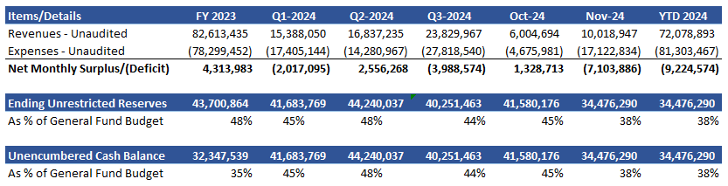
(Unaudited and Subject to Change)

The above fund balance analysis is not audited and is subject to change. As of November 30, 2024, the unrestricted fund balance is estimated at $34.5 million, which equates to 38 percent of the annual budget. Not all revenues and expenditures for the fiscal period are recognized, and the above amount will change as and when yearend accruals and adjustments are added. During the month of November, the Village executed major inter-fund transfers. This was a planned and budgeted item. The yearend accruals and adjustments will further improve the ending restricted fund balance. In 2023, the Village revised its Fund Balance Policy, and the new target is set to maintain the fund balance between 30 and 50 percent. Besides that, an Economic Emergency Fund was established in 2023, and a transfer of $6.5 million was executed as initial funding from the General Fund reserves. The Village funded the second installment of $6.5 million for the Economic Emergency Fund in July 2024 from the 2023 audited surplus (General Fund), reducing the overall fund balance starting in July 2024. During November 2024, the financial activities resulted in a net deficit of $7.1 million for the General Fund, mainly due to inter-fund transfers. The year-to-date financial activities have resulted in a deficit of $9.2 million. The overall fund balance is expected to increase between December 2024 and March 2025.

Economic Emergency Fund

The Village Board authorized the creation of a new Economic Emergency Fund in May 2023 and approved a budget amendment funding $6.5 million from the General Fund reserves as an initial funding amount. This transfer was executed in May 2023 and invested in June 2023 in a AAA-rated I-prime account. The table below summarizes the Economic Emergency Fund activities for the month. During July 2024, the Village funded the second installment of $6.5 million. Also, the Economic Emergency Fund earned an interest income of $85,287 during November 2024. As of November 30, 2024, the Economic Emergency Fund reported an ending fund balance of $13.67 million, which comprises $13.0 million in the Village Contributions from the General Fund and $673,660 in the interest income.
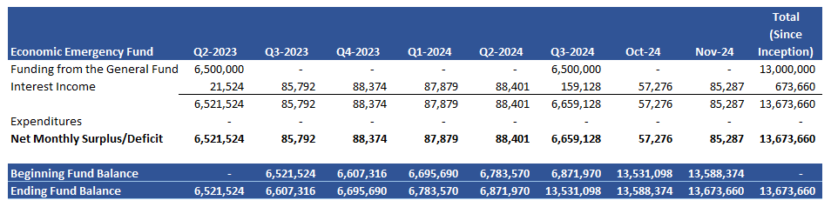

- Other Items:

  - During November 2025, the Village issued 105 real estate transfer tax stamps, of which 40 were exempt and 65 were non-exempt. During the month under review, the Village collected $70,908 in real estate transfer taxes. The average selling price for real estate was $363,569. At the same time last year (November 2023), the Village sold 94 transfer tax stamps, of which 39 were exempt and 55 were non-exempt. In the same month last year, the Village collected real estate transfer tax totaling $208,476, and the average selling price was $469,168.

Respectfully Submitted,
Amit Thakkar
Director of Finance

